**\* History of PHP \***

**PHP Tools, FI, Construction Kit, and PHP/FI .**PHP as it's known today is actually the successor to a product named PHP/FI. Created in **1994** by **Rasmus Lerdorf**, the very first incarnation of PHP was a simple set of Common Gateway Interface **(CGI)** binaries written in the C programming language. Originally used for tracking visits to his online resume, he named the suite of scripts "Personal Home Page Tools," more frequently referenced as "PHP Tools." Over time, more functionality was desired, and Rasmus rewrote PHP Tools, producing a much larger and richer implementation. This new model was capable of database interaction and more, providing a framework upon which users could develop simple dynamic **web applications** such as guestbooks. In **June of 1995.**

**Rasmus**  released the source code for PHP Tools to the public, which allowed developers to use it as they saw fit. This also permitted - and encouraged - users to provide fixes for bugs in the code, and to generally improve upon it.

In September of that year, Rasmus expanded upon PHP and - for a short time - actually dropped the PHP name. Now referring to the tools as **FI (short for "Forms Interpreter")**, the new implementation included some of the basic functionality of PHP as we know it today. It had Perl-like variables, automatic interpretation of form variables, and HTML embedded syntax. The syntax itself was similar to that of Perl, albeit much more limited, simple, and somewhat inconsistent. In fact, to embed the code into an HTML file, developers had to use HTML comments. Though this method was not entirely well-received, **FI** continued to enjoy growth and acceptance as a CGI tool --- but still not quite as a language. However, this began to change the following month; in **October, 1995**, Rasmus released a complete rewrite of the code. Bringing back the PHP name, it was now (briefly) named **"Personal Home Page Construction Kit,"** and was the first release to boast what was, at the time, considered an advanced scripting interface. The language was deliberately designed to resemble C in structure, making it an easy adoption for developers familiar with C, Perl, and similar languages. Having been thus far limited to UNIX and POSIX-compliant systems, the potential for a Windows NT implementation was being explored.

The code got another complete makeover, and in **April of 1996**, combining the names of past releases, Rasmus introduced PHP/FI. This second-generation implementation began to truly evolve PHP from a suite of tools into a programming language in its own right. It included built-in support for DBM, mSQL, and Postgres95 databases, cookies, user-defined function support, and much more. That June, PHP/FI was given a version 2.0 status. An interesting fact about this, however, is that there was only one single full version of PHP 2.0. When it finally graduated from beta status in November, 1997, the underlying parsing engine was already being entirely rewritten.

Though it lived a short development life, it continued to enjoy a growing popularity in still-young world of web development. In 1997 and 1998, PHP/FI had a cult of several thousand users around the world. A Netcraft survey as of May, 1998, indicated that nearly **60,000 domains** reported having headers containing "PHP", indicating that the host server did indeed have it installed. This number equated to approximately 1% of all domains on the Internet at the time. Despite these impressive figures, the maturation of PHP/FI was doomed to limitations; while there were several minor contributors, it was still primarily developed by an individual.

**WELCOME**

Welcome to Travelife for Tour Operators & Travel Agencies Travelife is a leading training, management and certification initiative for tourism companies committed to reach sustainability.Operating your business in a socially and environmentally friendly manner makes good business sense! Both consumer and business demand for responsible products is growing and the public wants to know how you manage your business.Companies ready to get to work towards sustainability will therefore score better on customer satisfaction, staff motivation and business efficiency with positive effects for their competitive advantage. Sustainability management is all about commitment and consistent sustainable business practices. This includes your products , how you monitor and manage your impacts, and how you support your suppliers on their road to sustainability.Travelife for Tour operators

Travelife is a fair and affordable system which helps tour operators and travel agencies to manage and improve social and environmental impacts by complying with sustainability criteria. Ultimately, when a company meets the requirements, it will receive a Travelife award.To support you on your road to sustainability, Travelife offers a wide range of services which include training, management, planning, reporting and B2B tools. Detailed information can be found under ´Tools´.Joining Travelife is easy!Joining Travelife is easy and affordable. Our practical web-based solutions make Travelife convenient for both small and (very) large companies. Step-by-step we will guide you towards sustainability. To find out more about Travelife for Tour Operators and Travel Agencies or to join, please visit `membership´. Alternatively you can contact our team by submitting our enquiry form.

**Abstract :**

Online Tour and Traveling Booking is a system that gives you facility of booking any type of Tours and Travels.This system is made so that Customer will not have to Come to us to Book his\her Tours.The project ‘Tours and Travels Management System’ is developed to replace the currently existing system, which helps in keeping records of the customer,details of destination as well as payment received.In the present era where “time” proves to be the most important asset for an individual by

replacing the current register system to fully computerize, it not only saves the precious asset that is time, but also accuracy, reliability and uniformity can be maintained.This project is useful for the manager of the company as it helps them to search the data faster than existing system, to get customer record easily and report of the customer, payment, etc are generated as per requirement.

**Description :**

Tours & Travels Management System Transport solution to the different companies situated locally in the many districts and it organizes tours to various part of

the country. Earlier all the processes were done manually.The manual process is done by maintaining the details of the tours,employees and their customers.

**1) Employee Details :**

Details of the employees of the system is maintained in the office.It includes details of both the moving staff (driver) and the non-moving staff (clerk).

Details related to the salary of the employees is maintained.Salary of the clerk and the manager is calculated on the basis of monthly attendance and the salary of

the driver is calculated on the basis of the trips made by the drivers.Salary of the employees are deducted on the basis of absence made by the employee.

Details of no. of days the employee remained absent in a month is also maintained.

2) Tour Details :

Details of different types of tours which includes tours like family tours,couple tours,general tours,date and time of departure and the fair of the tours etc are

maintained. As the customer ask for the details of a particular tour, the clerk gives the details of the related place where he/she wants to go and the date and time

of the tour, no. of seats available of that particular tour, fair of the tour, details of discount on a particular tour package if any. Clark also guides the customer

by giving the details of the forthcoming tours with the probable date and time.

**Taxi**

**Car**

**Bus**

**Index Page/Home Page**

LogIn

**Servicess**

**Quick Access**

**Car**

**Bus**

**Taxi**

**T**ours and travels management system project is a web based application useful for managing different types of bookings for using a single application. This application is developed in asp.net programming language.

Advantages of Tours and Travels Management System Project:

One-stop shopping – When it comes to flight arrangements, railway arrangements, rental cars, tour excursions, cruise information and accommodation, and hotels, travel agents have a lot of clout. They can provide a complete travel package, including shuttle service to and from the airport and even the services of a personal tour guide if requested. By doing all your travel and travel-related shopping with a reputable online travel agency, there is no telling how much you can get done within a short amount of time.

Last minute booking- It used to be that travelling last minute was expensive. Not anymore with online travel agents! In many cases, unsold seats on flights or unsold rooms in hotels are offered to travel agents a few weeks before departure date at considerably discounted rates so they can be sold immediately. If you are travelling last minute, ask your online travel agent for last minute budget deals. Chances are you might get what you want, provided your travel dates don’t fall within peak travel times. But you have to ask, not assume that it will be offered automatically!

Explanation of Few modules in this project:

Customer Reservation:

The customer are given the facility to make online directly.Theyhas to register themselves as registered customers. It is made to authentication of the customers, exchange of cryptography keys, and creation of a profile for each traveler. Each customer is identified by the user name. The customer confirms their reservation or makes any query using the user id.

Online Ticket Reservation:

T ‘n’ T Travels allows its customers to reserve ticket online through its own site visit.com.Visit.com contains a huge information regarding all types of convenes throughout India in comparatively less price. Customer may select their own way of communication according to their requirements. Travels boasts of a modern and computerized infrastructure.This enables us to assure immediate reservations to ourcustomers and provide them with relevant online information. .The advantage of booking your online ticket is that you receive “e-tickets” instantly, which consist of a number that identifies your transaction. This not only saves your time but also helps you to compare and find the best deals on your travel.

**Index Page Degine View**

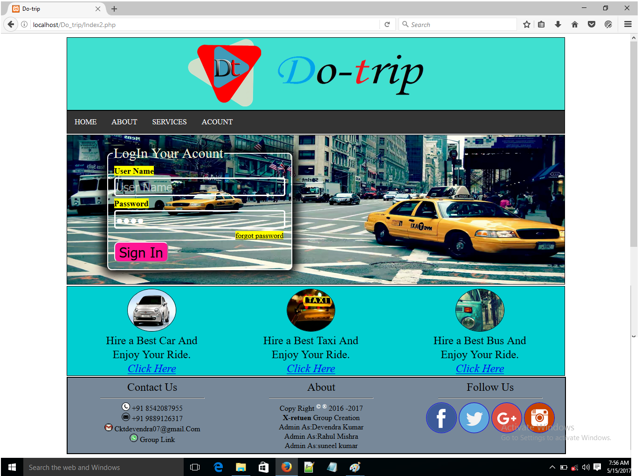

**\*Home Page/Index Page\***

**Index page.php**

<!DOCTYPE html>

<html>

<head>

<title>

Do-trip

</title>

</head>

<link href="Index2.css" rel="Stylesheet" type="text/css" />

<body>

<?php include'Header.php' ?>

<!--Login Section -->

<section id="LogIn_Sec">

<fieldset>

<legend> LogIn Your Acount</legend>

<form action="db_Index2.php" method="GET">

<table >

<tr>

<td >

<lable for="user_Name"><font size="4px" ><b><mark>User Name </mark></b></font></lable>

</td>

</tr>

<tr>

<td>

<input type="TextBox" placeholder="User Name" name="userID" class="textbox" tabIndex="1" autofocuse="autofocuse" />

</td>

</tr>

<tr>

<td >

<lable for="user_Name"><font size="4px" ><b><mark>Password </mark></b></font></lable>

</td>

</tr>

<tr>

<td>

<input type="password" placeholder="Password" name="Password" class="textbox" tabIndex="2" />

</td>

</tr>

<tr>

<td align="right">

<a href="forgot_password.php" tabIndex="3" ><mark>forgot password</mark></a>

</td>

</tr>

<tr>

<td align="left">

<!-- <Button type="Button" Id="Btn_Sign_Up" class="Buttons" tabIndex="5" onclick="Open_Reg_Page()" >SignUp</Button>-->

<input type="submit" Id="Btn_Login" value="Sign In" class="Buttons" tabIndex="4" />

</td>

</tr>

</table >

</form>

</fieldset>

</section>

<!-- Quick Acsess Content -->

<section id="Show_services_sec">

<section id="Bus_Rental_Sec">

<center>

<img src="Images/Bus.jpg" id="Img_Bus_Rental" class="Rental_Images" />

<br/>

<font size="5px">Hire a Best Bus And Enjoy Your Ride.

<br/>

<a href="Buses_page.php" Target="_blank" ><em>Click Here</em></a></font>

</center>

</section>

<section id="Taxi_Rental_Sec">

<center>

<img src="Images/Taxi1.jpg" id="Img_Taxi_Rental" class="Rental_Images" />

<br/>

<font size="5px">Hire a Best Taxi And Enjoy Your Ride.

<br/>

<a href="Taxi_page.php" Target="_blank" ><em>Click Here</em></a></font>

</center>

</section>

<section id="Car_Rental_Sec">

<center>

<img src="Images/Car2.jpg" id="Img_Car_Rental" class="Rental_Images" />

<br/>

<font size="5px">Hire a Best Car And Enjoy Your Ride.

<br/>

<a href="Car_page.php" Target="_blank" ><em>Click Here</em></a></font>

</center>

</section>

</section>

<!-- Footer Section -->

<footer>

<section id="Follow_Us_footer">

<center><lable for="Follow_Us"><font size="5px">Follow Us</font></lable></center>

<hr width="70%"/>

<center>

<a href="https://www.fecebook.com"><img src="Images/Facebook.png" id="Facebook" class="Follow_Images" /></a>

<a href="https://www.twiter.com"><img src="Images/Twiter.png" id="Twiter" class="Follow_Images" /></a>

<a href="https://www.gmail.com"><img src="Images/Google+.png" id="Google+" class="Follow_Images" /></a>

<a href="https://www.Instragram.com"><img src="Images/Instagram.png" id="Instragram" class="Follow_Images" /></a>

</center>

</section>

<section id="About">

<center><lable for="About"><font size="5px">About</font></lable></center>

<hr width="70%"/>

<center>

Copy Right <font color="#fff"><sup>&copy; &reg;</sup> </font>2016 -2017

<br/>

<strong>X-retuen</strong> Group Creation

<br/>

Admin As:Devendra Kumar<br/>

Admin As:Rahul Mishra<br/>

Admin As:suneel kumar

</center>

</section>

<section id="Contact_Us_footer">

<center><lable for="Contact_Us"><font size="5px">Contact Us</font></lable></center>

<hr width="70%"/>

<center>

<img src="Images/context.png" id="Context" class="Conctact_Images" />

+91 8542087955

<br/>

<img src="Images/Message.png" id="Message" class="Conctact_Images" />

+91 9889126317

<br/>

<img src="Images/Gmail.png" id="gmail" class="Conctact_Images" />

Cktdevendra07@gmail.Com

<br/>

<img src="Images/Whatsaap.png" id="Whatsaap" class="Conctact_Images" />

Group Link<br/><br/>

</center>

</section>

</footer>

</body>

</html>

**Index page.css**

#LogIn_Sec { margin-left:10% ; border: 1px solid; width: 80%; background-image: url('Images/LogIn_image.png'); height:20em;background-size: cover; background-repeat: no-repeat; background-position: center center; }

fieldset{border: 2px solid white; width: 35%;margin:2% 0 0 8%; border-radius: 10px; box-shadow: 0px 0px 20px 10px ; }

legend{color: beige; font-size: 30px}

table{ width: 99%; background:; color: white; }

.textbox{font-size: 25px; width: 99%; background:inherit; color: white; border: 3px solid; border-radius: 5px}

#Btn_Login{font-size: 30px; background:deeppink; border-radius: 10px; }

#Btn_Sign_Up{font-size: 30px;background:deeppink; border-radius: 10px;}

#Show_services_sec{border: 1px solid; width: 80%; height: auto; margin:2px 0 0 10% ; background:darkturquoise}

#Taxi_Rental_Sec,#Bus_Rental_Sec,#Outher_Rental_Sec{border: 0px dotted;margin:5px 5% 0 0; width: 24%; float:right}

#Taxi_Rental_Sec{margin-right: 10%;}

#Car_Rental_Sec{border: 0px dotted; margin:5px 0 0 5%; width: 24%;}

.Rental_Images{border: 1px solid; width: 40%; height:90px; border-radius: 50%; }

footer{border: 2px solid; margin-top: 2px; width: 80%; margin-left:10% ; background: #778899;}

footer>#Follow_Us_footer{border: 0px solid; width: 30%; float: right; margin-top:5px }

footer>#About{border: 0px solid; width: 30%; float: right; margin-right: 4%;margin-top:5px }

footer>#Contact_Us_footer{border: 0px solid; width: 30%; margin-left: 2%;margin-top:5px}

.Follow_Images{border:1px solid; width: 20%; border-radius: 50% }

.Conctact_Images{border:1px solid; width: 5%; border-radius: 50% }

**db_Index2.php(Database)**

<?php

$ID=$_GET['userID'];

$pass=$_GET['Password'];

if($ID=='admin')

{

if($pass=='root')

{

include 'Services.php';

}

else

{

echo "<script> alert('Incorect Password..!') </script>";

}

}

else

{

echo "<script> alert('Incorect UserID..!') </script>";

}

?>

**\*Rantal SERVICES Degine Page\***

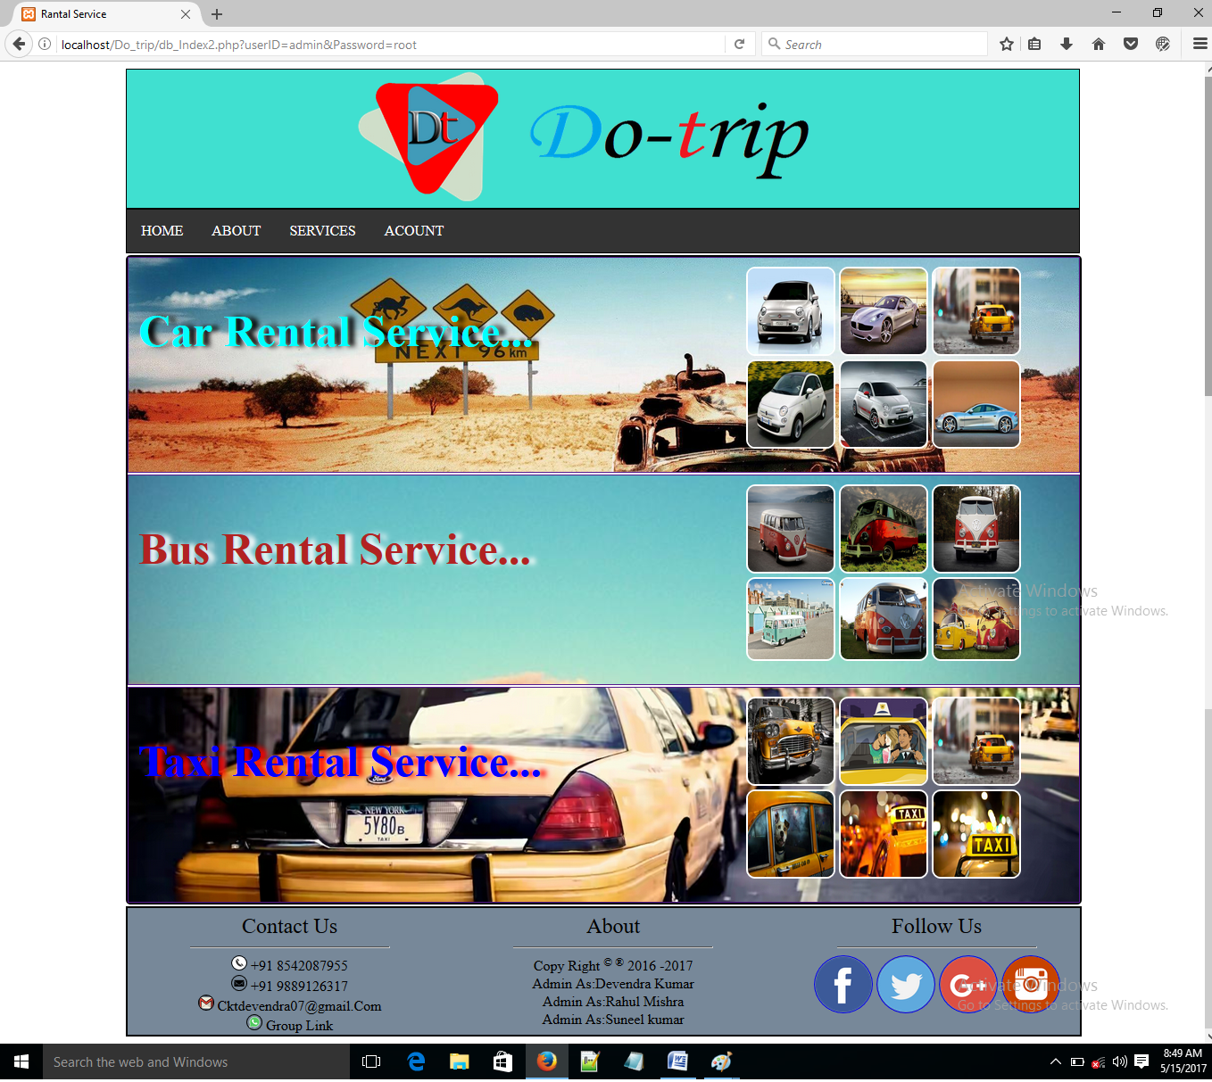

**\*SERVICES\***

**Service.php**

<!DOCTYPE html>

<html lang = "en-US">

<head>

<title>

Rantal Service

</title>

</head>

<link rel = "stylesheet" type = "text/css" href = "Service.css" />

<body>

<?php include 'Header.php' ?>

<section id="ItemColector_Sec" >

<!-- Car Rantal Service Section-->

<a href="Car_page.php">

<section id="Car_Sec" >

<section class="IMGGroup_Sec">

<img class="IMG" src="Images/Cars/Car1.jpg" />

<img class="IMG" src="Images/Cars/Car2.jpg" />

<img class="IMG" src="Images/Cars/Car3.jpg" />

<br/>

<img class="IMG" src="Images/Cars/Car4.jpg" />

<img class="IMG" src="Images/Cars/Car5.jpg" />

<img class="IMG" src="Images/Cars/Car6.jpg" />

</section>

<section class="information_sec">

<font style="font-size:50px; color:aqua; text-shadow: 7px 0px 5px black; ">

<b>Car Rental Service...</b>

</font><br/>

<font style="font-size:25px; ">click anywhere and choose your <br/><Strong>CAR</Strong>

for your trip<br/>

</font>

</lable>

</section>

</section></a>

<!-- Bus Rantal Service Section-->

<a href="Buses_page.php">

<section id="Bus_Sec" >

<section class="IMGGroup_Sec">

<img class="IMG" src="Images/Buss/Bus20.jpg" />

<img class="IMG" src="Images/Buss/Bus21.jpg" />

<img class="IMG" src="Images/Buss/Bus22.jpg" />

<br/>

<img class="IMG" src="Images/Buss/Bus23.jpg" />

<img class="IMG" src="Images/Buss/Bus24.jpg" />

<img class="IMG" src="Images/Buss/Bus25.jpg" />

</section>

<section class="information_sec">

<font style="font-size: 50px; color:firebrick; text-shadow: 7px 0px 5px white; ">

<b>Bus Rental Service...</b>

</font><br/>

<font style="font-size:25px; ">click anywhere and choose your <br/> <Strong>BUS</Strong>

for your trip<br/>

</font>

</section>

</section></a>

<!-- Taxi Rantal Service Section-->

<a href="Taxi_page.php">

<section id="Taxi_Sec" >

<section class="IMGGroup_Sec">

<img class="IMG" src="Images/Taxi/Taxi1.jpg" />

<img class="IMG" src="Images/Taxi/Taxi2.jpg" />

<img class="IMG" src="Images/Taxi/Taxi3.jpg" />

<br/>

<img class="IMG" src="Images/Taxi/Taxi4.jpg" />

<img class="IMG" src="Images/Taxi/Taxi5.jpg" />

<img class="IMG" src="Images/Taxi/Taxi6.jpg" />

</section>

<section class="information_sec">

<font style="font-size:50px; color:blue; text-shadow: 7px 0px 5px red; ">

<b>Taxi Rental Service...</b>

</font><br/>

<font style="font-size:25px; color:white; ">click anywhere and choose your <br/><Strong>TAXI</Strong>

for your trip<br/>

</font>

</section>

</section></a>

</section>

<?php include 'Footer2.php' ?>

</body>

</html>

**Service.css**

#ItemColector_Sec{border: 2px solid;width: 80%;margin-left: 10%;height:auto;; border-radius: 5px;}

#Taxi_Sec,#Car_Sec,#Bus_Sec{border: 1px solid; width: auto; margin-top:2px; height: 15em;}

#Car_Sec{margin-top:0px;}

.IMG{border: 2px solid white; width: 30%; height:6em; border-radius: 10px;}

.IMGGroup_Sec{border: 0px solid; width:30%; height: 13em; margin: 10px 5% 0 0; float: right; background: }

.information_sec{border: 0px solid; width: 60%; margin:5% 0 0 1%}

#Car_Sec{background-image: url('Images/Cars/68815238-high-resolution-wallpapers.jpg');background-size: cover; background-repeat: no-repeat; background-position: center center;}

#Bus_Sec{background-image: url('Images/Cars/70401256-sunset-in-summer.jpeg');background-size: cover; background-repeat: no-repeat; background-position: center center;}

#Taxi_Sec{backgroundimage:url('Images/Taxi/Taxi13.jpg');background-size: cover; background-repeat: no-repeat; background-position: center center;} a{text-decoration: none;}

**\*Car Page Degine View\***

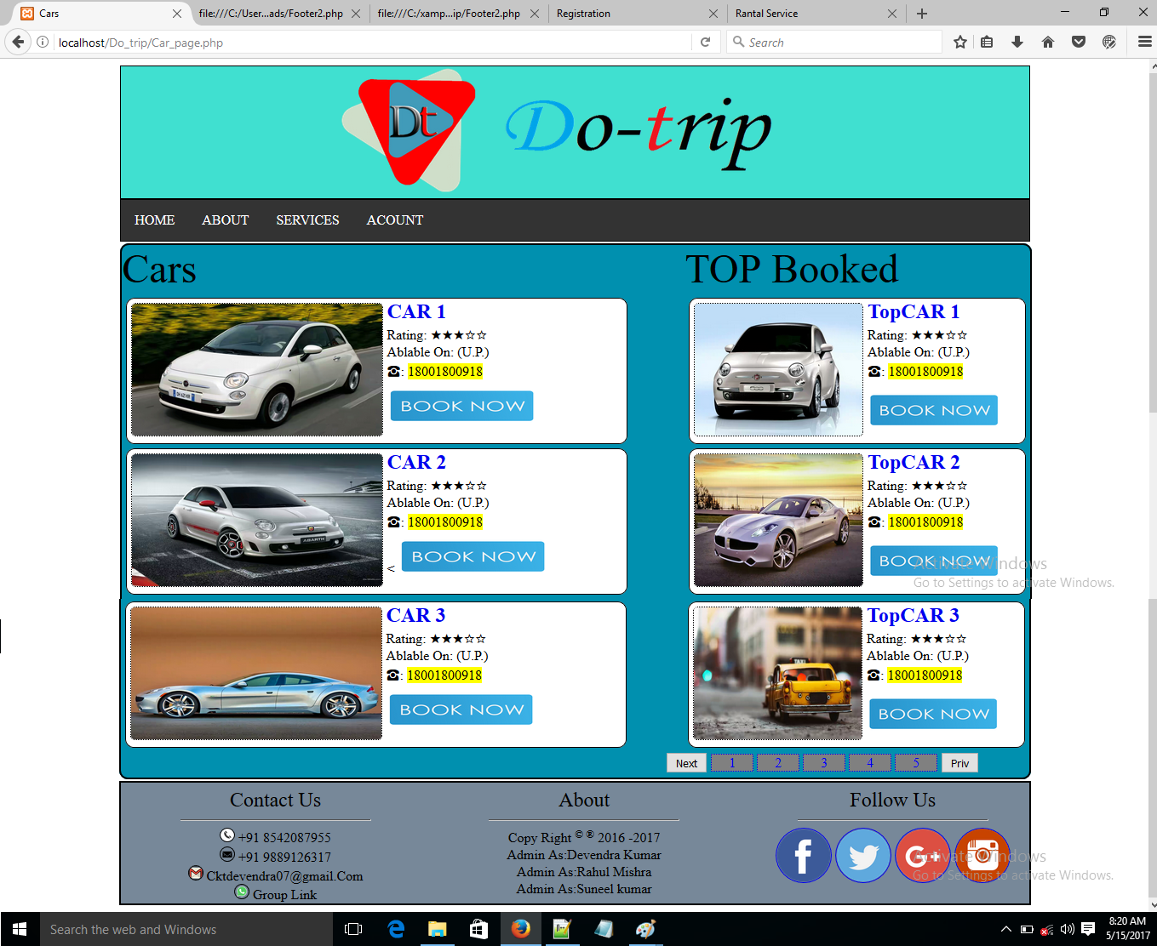

**Car_page.php**

<!DOCTYPE html>

<html>

<head>

<title>

Cars

</title>

</head>

<link href="Css/Cars_page.css" rel="Stylesheet" type="text/css" />

<body>

<?PHP include'Header.php' ?>

<!-- Top Cars.. -->

<section id="ItemColector_Sec">

<aside id="Right_Aside">

<font size="40px" >

<lable>TOP Booked </lable>

</font>

<section id="Top_CAR1_Sec" class="Top_Select_Car">

<img src="Images/Cars/Car1.jpg" id="Img_Top_Car1" align="left" hspace="5" vspace="5" class="Top_Cars_IMG_Class" />

<section class="Car_details" id="Top_car1">

<font size="5px" >

<a href="#"><b>TopCAR 1</b></a>

</font>

<br/>

<lable for="Rating">Rating: &starf;&starf;&starf;&star;&star;</lable>

<br/>

<lable for="Ablable">Ablable On: (U.P.)</lable>

<br/>

<lable for="Call">&phone;: <mark>18001800918</mark> </lable>

<br/>

<a href="Fill_Information.php" class="hypBook_Now">

<img src="Images/Book_Now.png" class="TopBook_images" />

</a>

</section>

</section>

<section id="Top_CAR1_Sec" class="Top_Select_Car">

<img src="Images/Cars/Car2.jpg" id="Img_Top_Car2" align="left" hspace="5" vspace="5" class="Top_Cars_IMG_Class" />

<section class="Car_details" id="Top_car2">

<font size="5px">

<a href="#"><b>TopCAR 2</b></a>

</font>

<br/>

<lable for="Rating">Rating: &starf;&starf;&starf;&star;&star;</lable>

<br/>

<lable for="Ablable">Ablable On: (U.P.)</lable>

<br/>

<lable for="Call">&phone;: <mark>18001800918</mark> </lable>

<br/>

<a href="Fill_Information.php" class="hypBook_Now">

<img src="Images/Book_Now.png" class="TopBook_images" />

</a>

</section>

</section>

<section id="Top_CAR1_Sec" class="Top_Select_Car">

<img src="Images/Cars/Car3.jpg" id="Img_Top_Car3" align="left" hspace="5" vspace="5" class="Top_Cars_IMG_Class" />

<section class="Car_details" id="Top_car3">

<font size="5px">

<a href="#"><b>TopCAR 3</b></a>

</font>

<br/>

<lable for="Rating">Rating: &starf;&starf;&starf;&star;&star;</lable>

<br/>

<lable for="Ablable">Ablable On: (U.P.)</lable>

<br/>

<lable for="Call">&phone;: <mark>18001800918</mark> </lable>

<br/>

<a href="Fill_Information.php" class="hypBook_Now">

<img src="Images/Book_Now.png" class="TopBook_images" />

</a>

</section>

</section>

</aside>

<!-- Related Cars.. -->

<font size="40px" >

<lable>Cars </lable>

</font>

<section id="CAR1_Sec" class="Select">

<img src="Images/Cars/Car4.jpg" id="Img_Car1" align="left" hspace="5" vspace="5" class="IMG_Class" />

<section class="Car_details" id="car1">

<font size="5px">

<a href="#"><b>CAR 1</b></a>

</font>

<br/>

<lable for="Rating">Rating: &starf;&starf;&starf;&star;&star;</lable>

<br/>

<lable for="Ablable">Ablable On: (U.P.)</lable>

<br/>

<lable for="Call">&phone;: <mark>18001800918</mark> </lable>

<br/>

<a href="Fill_Information.php" class="hypBook_Now">

<img src="Images/Book_Now.png" class="Book_images" />

</a>

</section>

</section>

<section id="CAR2_Sec" class="Select">

<img src="Images/Cars/Car5.jpg" id="Img_Car2" align="left" hspace="5" vspace="5" class="IMG_Class" />

<section class="Car_details" id="car2">

<font size="5px">

<a href="#"><b>CAR 2</b></a>

</font>

<br/>

<lable for="Rating">Rating: &starf;&starf;&starf;&star;&star;</lable>

<br/>

<lable for="Ablable">Ablable On: (U.P.)</lable>

<br/>

<lable for="Call">&phone;: <mark>18001800918</mark> </lable>

<br/>

<<a href="Fill_Information.php" class="hypBook_Now">

<img src="Images/Book_Now.png" class="Book_images" />

</a>

</section>

</section>

<section id="CAR3_Sec" class="Select">

<img src="Images/Cars/Car6.jpg" id="Img_Car3" align="left" hspace="5" vspace="5" class="IMG_Class" />

<section class="Car_details" id="car3">

<font size="5px">

<a href="#"><b>CAR 3</b></a>

</font>

<br/>

<lable for="Rating">Rating: &starf;&starf;&starf;&star;&star;</lable>

<br/>

<lable for="Ablable">Ablable On: (U.P.)</lable>

<br/>

<lable for="Call">&phone;: <mark>18001800918</mark> </lable>

<br/>

<a href="Fill_Information.php" class="hypBook_Now">

<img src="Images/Book_Now.png" class="Book_images" />

</a>

</section>

</section>

<section id="Numbring_Index_sec">

<Button type="Button" id="Btn_Next" onclick="" class="Buttons">Next</Button>

<a href="#" class="Numbring_page" Target="_blank">1</a>

<a href="#" class="Numbring_page">2</a>

<a href="#" class="Numbring_page">3</a>

<a href="#" class="Numbring_page">4</a>

<a href="#" class="Numbring_page">5</a>

<Button type="Button" id="Btn_Prive" onclick="" class="Buttons">Priv</Button>

</section>

</section>

<?PHP include'Footer2.php' ?>

</body>

</html>

**Car_page.css**

#ItemColector_Sec {border: 2px solid;width: 80%;margin-left:10%;height:auto;;border-radius: 10px; background: #0090af}

#Right_Aside{ width: 38%; float: right; margin: auto; height:auto; }

.Top_Select_Car{border: 1px solid; margin: 5px; width: 97%; height:170px; border-radius: 10px; background: white;}

.Top_Cars_IMG_Class{border: 1px dotted; width: 50%; height: 155px; border-radius: 5px; }

.Select{border: 1px solid; margin: 5px; width: 55%; height:170px; border-radius: 10px; background: white; }

.IMG_Class{border: 1px dotted; width: 50%; height: 155px; border-radius: 5px;}

a{text-decoration: none;}

.Taxi_details{border: 1px solid; width: 40%; float: right; margin: 3% 5% 0px 0px; height: auto;}

.hypBook_Now{ }

.TopBook_images{width: 40%; height:40px ; margin-top: 15px; }

.Book_images{width: 30%; height: 40px; margin-top: 10px }

#Numbring_Index_sec{border: px solid; width:40%; margin:0 0 5px 60%; float: ri }

.Numbring_page{ border: 1px dotted; margin-left: 0px; padding:0px 20px; background:grey; & }

**\*Bus Page Degine View\***

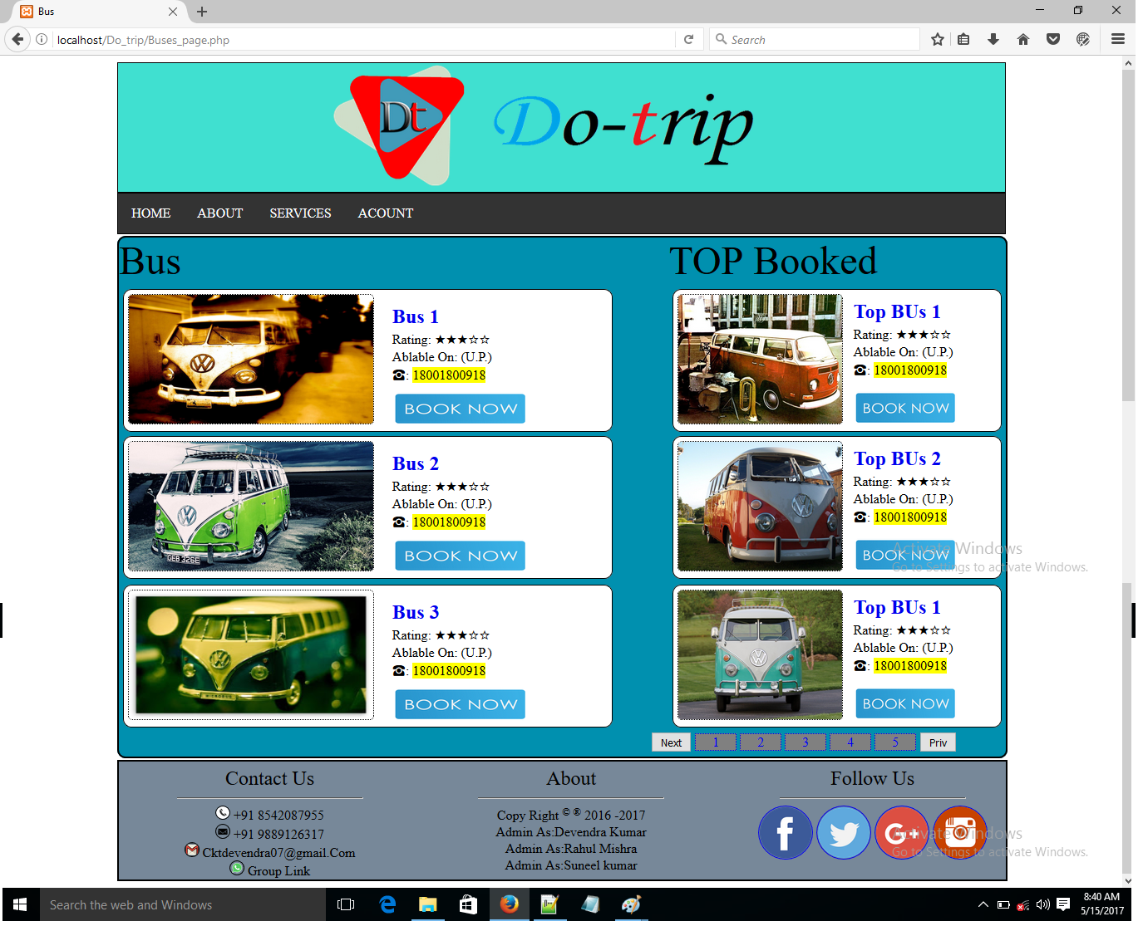

**Bus_page.php**

<!DOCTYPE html>

<html>

<head>

<title>

Bus

</title>

</head>

<link href="Css/Buses_page.css" rel="Stylesheet" type="text/css" />

<body>

<?PHP include'Header.php' ?>

<!-- Top Cars.. -->

<section id="ItemColector_Sec">

<aside id="Right_Aside">

<font size="40px" >

<lable>TOP Booked </lable>

</font>

<section id="Top_Bus_Sec" class="Top_Select_Bus">

<img src="Images/Buss/Bus14.jpg" id="Img_Top_Bus1" align="left" hspace="5" vspace="5" class="Top_Bus_IMG_Class" />

<section class="Bus_details" id="Top_Bus1">

<font size="5px" >

<a href="#"><b>Top BUs 1</b></a>

</font>

<br/>

<lable for="Rating">Rating: &starf;&starf;&starf;&star;&star;</lable>

<br/>

<lable for="Ablable">Ablable On: (U.P.)</lable>

<br/>

<lable for="Call">&phone;: <mark>18001800918</mark> </lable>

<br/>

<a href="Fill_Information.php" class="hypBook_Now">

<img src="Images/Book_Now.png" class="TopBook_images" />

</a>

</section>

</section>

<section id="Top_Bus_Sec" class="Top_Select_Bus">

<img src="Images/Buss/Bus24.jpg" id="Img_Top_Bus2" align="left" hspace="5" vspace="5" class="Top_Bus_IMG_Class" />

<section class="Bus_details" id="Top_Bus2">

<font size="5px" >

<a href="#"><b>Top BUs 2</b></a>

</font>

<br/>

<lable for="Rating">Rating: &starf;&starf;&starf;&star;&star;</lable>

<br/>

<lable for="Ablable">Ablable On: (U.P.)</lable>

<br/>

<lable for="Call">&phone;: <mark>18001800918</mark> </lable>

<br/>

<a href="Fill_Information.php" class="hypBook_Now">

<img src="Images/Book_Now.png" class="TopBook_images" />

</a>

</section>

</section>

<section id="Top_Bus_Sec" class="Top_Select_Bus">

<img src="Images/Buss/Bus26.jpg" id="Img_Top_Bus3" align="left" hspace="5" vspace="5" class="Top_Bus_IMG_Class" />

<section class="Bus_details" id="Top_Bus3">

<font size="5px" >

<a href="#"><b>Top BUs 1</b></a>

</font>

<br/>

<lable for="Rating">Rating: &starf;&starf;&starf;&star;&star;</lable>

<br/>

<lable for="Ablable">Ablable On: (U.P.)</lable>

<br/>

<lable for="Call">&phone;: <mark>18001800918</mark> </lable>

<br/>

<a href="Fill_Information.php" class="hypBook_Now">

<img src="Images/Book_Now.png" class="TopBook_images" />

</a>

</section>

</section>

</aside>

<!-- Related Cars.. -->

<font size="40px" >

<lable>Bus</lable>

</font>

<section id="Bus_Sec" class="Select">

<img src="Images/Buss/Bus29.jpg" id="Img_Bus5" align="left" hspace="5" vspace="5" class="IMG_Class" />

<section class="Bus_details" id="Bus1">

<font size="5px">

<a href="#"><b>Bus 1</b></a>

</font>

<br/>

<lable for="Rating">Rating: &starf;&starf;&starf;&star;&star;</lable>

<br/>

<lable for="Ablable">Ablable On: (U.P.)</lable>

<br/>

<lable for="Call">&phone;: <mark>18001800918</mark> </lable>

<br/>

<a href="Fill_Information.php" class="hypBook_Now">

<img src="Images/Book_Now.png" class="Book_images" />

</a>

</section>

</section>

<section id="Bus_Sec" class="Select">

<img src="Images/Buss/Bus2.jpg" id="Img_Bus6" align="left" hspace="5" vspace="5" class="IMG_Class" />

<section class="Bus_details" id="Bus2">

<font size="5px">

<a href="#"><b>Bus 1</b></a>

</font>

<br/>

<lable for="Rating">Rating: &starf;&starf;&starf;&star;&star;</lable>

<br/>

<lable for="Ablable">Ablable On: (U.P.)</lable>

<br/>

<lable for="Call">&phone;: <mark>18001800918</mark> </lable>

<br/>

<a href="Fill_Information.php" class="hypBook_Now">

<img src="Images/Book_Now.png" class="Book_images" />

</a>

</section>

</section>

<section id="Bus_Sec" class="Select">

<img src="Images/Buss/Bus6.jpg" id="Img_Car6" align="left" hspace="5" vspace="5" class="IMG_Class" />

<section class="Bus_details" id="Bus6">

<font size="5px">

<a href="#"><b>Bus 6</b></a>

</font>

<br/>

<lable for="Rating">Rating: &starf;&starf;&starf;&star;&star;</lable>

<br/>

<lable for="Ablable">Ablable On: (U.P.)</lable>

<br/>

<lable for="Call">&phone;: <mark>18001800918</mark> </lable>

<br/>

<a href="Fill_Information.php" class="hypBook_Now">

<img src="Images/Book_Now.png" class="Book_images" />

</a>

</section>

</section>

<section id="Numbring_Index_sec">

<Button type="Button" id="Btn_Next" onclick="" class="Buttons">Next</Button>

<a href="#" class="Numbring_page" Target="_blank">1</a>

<a href="#" class="Numbring_page">2</a>

<a href="#" class="Numbring_page">3</a>

<a href="#" class="Numbring_page">4</a>

<a href="#" class="Numbring_page">5</a>

<Button type="Button" id="Btn_Prive" onclick="" class="Buttons">Priv</Button>

</section>

</section>

<?PHP include'Footer2.php' ?>

</body>

</html>

**Bus_page.css**

#ItemColector_Sec {border: 2px solid;width: 80%;margin-left:10%;height:auto;;border-radius: 10px; background: #0090af}

#Right_Aside{ width: 38%; float: right; margin: auto; height:auto; }

.Top_Select_Bus{border: 1px solid; margin: 5px; width: 97%; height:170px; border-radius: 10px; background: white;}

.Top_Bus_IMG_Class{border: 1px dotted; width: 50%; height: 155px; border-radius: 5px; }

.Select{border: 1px solid; margin: 5px; width: 55%; height:170px; border-radius: 10px; background: white; }

.IMG_Class{border: 1px dotted; width: 50%; height: 155px; border-radius: 5px;}

a{text-decoration: none;}

.Bus_details{border: 0px solid; width: 40%; float: right; margin: 3% 5% 0px 0px; height: auto;}

.TopBook_images{width: 80%; height:40px ; margin-top: 15px; }

.Book_images{width: 70%; height: 40px; margin-top: 10px }

#Numbring_Index_sec{border: px solid; width:40%; margin:0 0 5px 60%; float: ri }

.Numbring_page{ border: 1px dotted; margin-left: 0px; padding:0px 20px; background:grey; & }

**\*Taxi Page Degine View\***

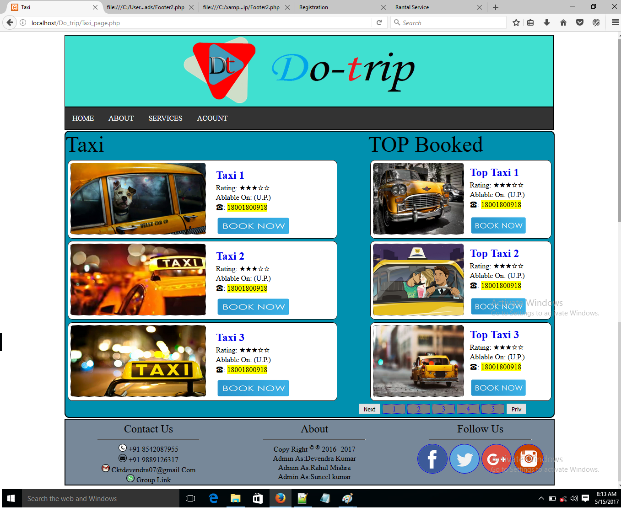

**Taxi_page.php**

<!DOCTYPE html>

<html>

<head>

<title>

Taxi

</title>

</head>

<link href="Css/Taxi_page.css" rel="Stylesheet" type="text/css" />

<body>

<?PHP include'Header.php' ?>

<!-- Top Cars.. -->

<section id="ItemColector_Sec">

<aside id="Right_Aside">

<font size="40px" >

<lable>TOP Booked </lable>

</font>

<section id="Top_Taxi_Sec" class="Top_Select_Taxi">

<img src="Images/Taxi/Taxi1.jpg" id="Img_Top_Taxi" align="left" hspace="5" vspace="5" class="Top_Taxi_IMG_Class" />

<section class="Taxi_details" id="Top_Taxi1">

<font size="5px" >

<a href="#"><b>Top Taxi 1</b></a>

</font>

<br/>

<lable for="Rating">Rating: &starf;&starf;&starf;&star;&star;</lable>

<br/>

<lable for="Ablable">Ablable On: (U.P.)</lable>

<br/>

<lable for="Call">&phone;: <mark>18001800918</mark> </lable>

<br/>

<a href="Fill_Information.php" class="hypBook_Now">

<img src="Images/Book_Now.png" class="TopBook_images" />

</a>

</section>

</section>

<section id="Top_Taxi_Sec" class="Top_Select_Taxi">

<img src="Images/Taxi/Taxi2.jpg" id="Img_Top_Taxi2" align="left" hspace="5" vspace="5" class="Top_Taxi_IMG_Class" />

<section class="Taxi_details" id="Top_car2">

<font size="5px">

<a href="#"><b>Top Taxi 2</b></a>

</font>

<br/>

<lable for="Rating">Rating: &starf;&starf;&starf;&star;&star;</lable>

<br/>

<lable for="Ablable">Ablable On: (U.P.)</lable>

<br/>

<lable for="Call">&phone;: <mark>18001800918</mark> </lable>

<br/>

<a href="Fill_Information.php" class="hypBook_Now">

<img src="Images/Book_Now.png" class="TopBook_images" />

</a>

</section>

</section>

<section id="Top_Taxi_Sec" class="Top_Select_Taxi">

<img src="Images/Taxi/Taxi3.jpg" id="Img_Top_Taxi3" align="left" hspace="5" vspace="5" class="Top_Taxi_IMG_Class" />

<section class="Taxi_details" id="Top_car2">

<font size="5px">

<a href="#"><b>Top Taxi 3</b></a>

</font>

<br/>

<lable for="Rating">Rating: &starf;&starf;&starf;&star;&star;</lable>

<br/>

<lable for="Ablable">Ablable On: (U.P.)</lable>

<br/>

<lable for="Call">&phone;: <mark>18001800918</mark> </lable>

<br/>

<a href="Fill_Information.php" class="hypBook_Now">

<img src="Images/Book_Now.png" class="TopBook_images" />

</a>

</section>

</section>

</aside>

<!-- Related Cars.. -->

<font size="40px" >

<lable>Taxi</lable>

</font>

<section id="Taxi_Sec" class="Select">

<img src="Images/Taxi/Taxi4.jpg" id="Img_Taxi4" align="left" hspace="5" vspace="5" class="IMG_Class" />

<section class="Taxi_details" id="Tax4">

<font size="5px">

<a href="#"><b>Taxi 1</b></a>

</font>

<br/>

<lable for="Rating">Rating: &starf;&starf;&starf;&star;&star;</lable>

<br/>

<lable for="Ablable">Ablable On: (U.P.)</lable>

<br/>

<lable for="Call">&phone;: <mark>18001800918</mark> </lable>

<br/>

<a href="Fill_Information.php" class="hypBook_Now">

<img src="Images/Book_Now.png" class="Book_images" />

</a>

</section>

</section>

<section id="Taxi_Sec" class="Select">

<img src="Images/Taxi/Taxi5.jpg" id="Img_Taxi5" align="left" hspace="5" vspace="5" class="IMG_Class" />

<section class="Taxi_details" id="Tax5">

<font size="5px">

<a href="#"><b>Taxi 2</b></a>

</font>

<br/>

<lable for="Rating">Rating: &starf;&starf;&starf;&star;&star;</lable>

<br/>

<lable for="Ablable">Ablable On: (U.P.)</lable>

<br/>

<lable for="Call">&phone;: <mark>18001800918</mark> </lable>

<br/>

<a href="Fill_Information.php" class="hypBook_Now">

<img src="Images/Book_Now.png" class="Book_images" />

</a>

</section>

</section>

<section id="Taxi_Sec" class="Select">

<img src="Images/Taxi/Taxi6.jpg" id="Img_Taxi6" align="left" hspace="5" vspace="5" class="IMG_Class" />

<section class="Taxi_details" id="Tax6">

<font size="5px">

<a href="#"><b>Taxi 6</b></a>

</font>

<br/>

<lable for="Rating">Rating: &starf;&starf;&starf;&star;&star;</lable>

<br/>

<lable for="Ablable">Ablable On: (U.P.)</lable>

<br/>

<lable for="Call">&phone;: <mark>18001800918</mark> </lable>

<br/>

<a href="Fill_Information.php" class="hypBook_Now">

<img src="Images/Book_Now.png" class="Book_images" />

</a>

</section>

</section>

<section id="Numbring_Index_sec">

<Button type="Button" id="Btn_Next" onclick="" class="Buttons">Next</Button>

<a href="#" class="Numbring_page" Target="_blank">1</a>

<a href="#" class="Numbring_page">2</a>

<a href="#" class="Numbring_page">3</a>

<a href="#" class="Numbring_page">4</a>

<a href="#" class="Numbring_page">5</a>

<Button type="Button" id="Btn_Prive" onclick="" class="Buttons">Priv</Button>

</section>

</section>

<?PHP include'Footer2.php' ?>

</body>

</html>

**Taxi_page.php**

#ItemColector_Sec {border: 2px solid;width: 80%;margin-left:10%;height:auto;;border-radius: 10px; background: #0090af}

#Right_Aside{ width: 38%; float: right; margin: auto; height:auto; }

.Top_Select_Taxi{border: 1px solid; margin: 5px; width: 97%; height:170px; border-radius: 10px; background: white;}

.Top_Taxi_IMG_Class{border: 1px dotted; width: 50%; height: 155px; border-radius: 5px; }

.Select{border: 1px solid; margin: 5px; width: 55%; height:170px; border-radius: 10px; background: white; }

.IMG_Class{border: 1px dotted; width: 50%; height: 155px; border-radius: 5px;}

a{text-decoration: none;}

.Taxi_details{border: 0px solid; width: 40%; float: right; margin: 3% 5% 0px 0px; height: auto;}

.hypBook_Now{ }

.TopBook_images{width: 80%; height:40px ; margin-top: 15px; }

.Book_images{width: 70%; height: 40px; margin-top: 10px }

#Numbring_Index_sec{border: px solid; width:40%; margin:0 0 5px 60%; float: ri }

.Numbring_page{ border: 1px dotted; margin-left: 0px; padding:0px 20px; background:grey; & }

**\*ACOUNT\***

**\*LogIn Page Degine View\***

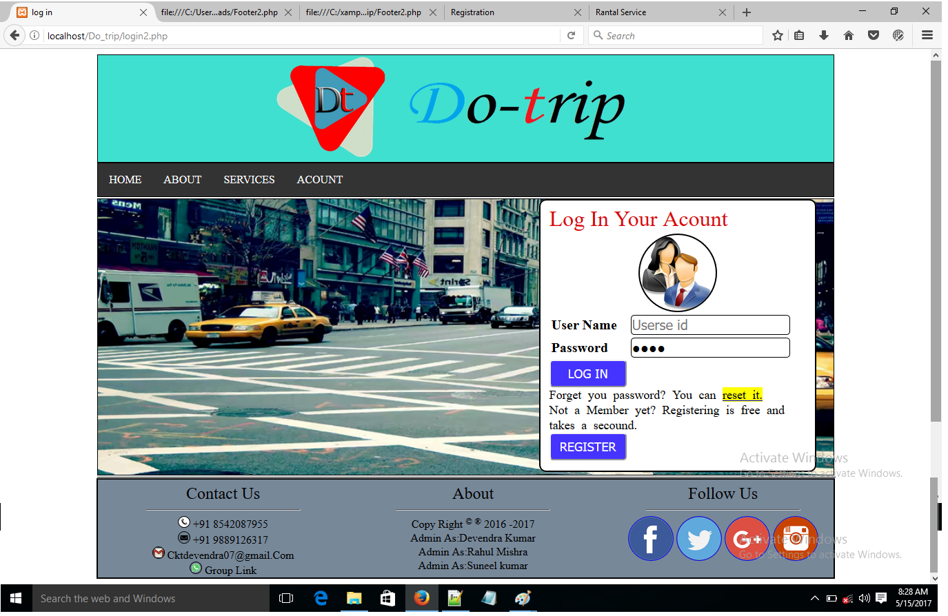

**Log_In.php**

<!DOCTYPE html>

<html>

<head>

<title>

log in

</title>

</head>

<link href="log_in2.css" rel="stylesheet" type="text/css"/>

<body>

<?php include'Header.php' ?>

<header>

<fieldset>

<font size="6" color="darkbule" background="yellow"> Log In Your Acount </font>

<form action="dbLog_in.php" method="POST" >

<table>

<tr>

<td colspan="2">

<center>

<img id="Icon_Image"src="icon_login_frm.png" align="center">

<center>

</td>

</tr>

<tr>

<td> <lable for="User_Name">User Name</lable> </td>

<td>

<input type="text" name"txtuser_id" id="txtUserName" placeholder="Userse id" />

</td>

</tr>

<tr>

<td>

<lable for="Password">Password</lable>

</td>

<td>

<input type="password" id="txtPass" name"txtpassword" placeholder="Password"/ >

</td>

</tr>

</table>

</form>

<section id="reg_forget">

<input type="submit" id="btnLogin" tabindex="3" value="LOG IN" />

<br/>

Forget you password? You can <a href="forgot_password.php" ><mark>reset it.</mark></a>

<br/>

Not a Member yet? Registering is free and takes a secound.

<br/>

<a href="Signup.php" >

<button type="button" id="btnLogin" tabindex="3" onclick=""> REGISTER</button>

</a>

</section>

</fieldset>

</header>

<?php include'Footer2.php' ?>

</body>

</html>

**Log_In.css**

header{width:80%;font-size:20px; margin:0% 0px 0px 10%; background: blue; border: 1px solid; background-image: url('Images/LogIn_image.png'); height:20em;background-size: cover; background-repeat: no-repeat; background-position: center center; }

#Icon_Image{ border-radius:50%; border:2px solid; width:30%; }

fieldset{border-radius: 10px; margin-left:60% ; margin-bottom: 10%; border: 2px solid; background: #ffffff; width:35% }

legend{font-size: 40px;}

table{width: 100%; font-weight: bold; }

#txtUserName,#txtPass{width: 90%; height: 25px; font-size: 20px; border:1px solid; border-radius:5px;}

#btnLogin{width: 30%; height: 30px; background-color: #4533ff; font-size: 18px; border-radius: 5px; color: #FFFFFF; height: 40px; }

#btnSigUp{width: 30%; height: 30px; background-color: #4533ff; font-size: 18px; border-radius: 5px;margin-left: 35%;color: #FFFFFF; height: 40px;}

#ForgetPasswordLink{font-size: 15px; margin-left: 50%; font-style: italic;}

#ForgetPasswordLink:active{background-color:blueviolet; }

#reg_forget{font-size: 18px; word-spacing: 5px}

**dbLog_In.php(Database)**

pacing: 5px}

**fplpfgl;lgf**

**df;l;sdg**

**sdg,;’lgsd**

**dsgl’ksgd**

**pklgdsplgsd**

**lpdgs**

**dsgklp[sdg**

**sdgllpsdg**

**pp;klp;sdg**

**];plgds**

**]klp;dsgl**

**]lkpsdgg**

Registration

**\*Registration Page Degine View\***

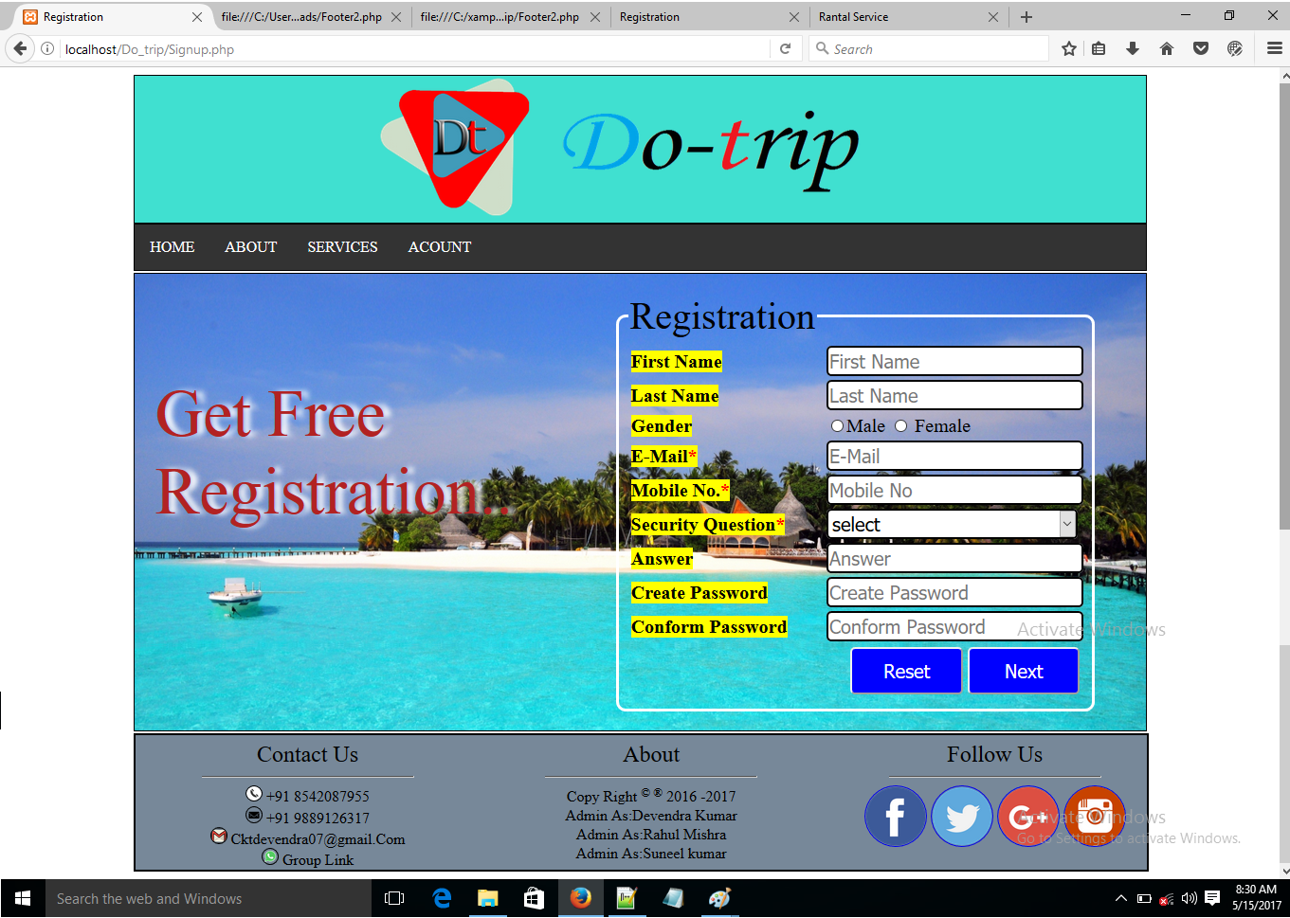

**Registration.php/ Signup.php**

<!DOCTYPE html>

<html lang = "en-US">

<head>

<title>

Registration

</title>

</head>

<link rel = "stylesheet" type = "text/css" href = "Registration.css" />

<body>

<?php include 'Header.php' ?>

<section id="Reg_sec" >

<form action="Reg_db.php" method="POST" name="form1">

<fieldset>

<legend>Registration</legend>

<table border="0px solod">

<tr>

<td>

<lable for="F_name"> First Name</lable>

</td>

<td>

<input type="TextBox" name="txtF_Name" class="TextBox" placeholder="First Name" required="required" >

</td>

</tr>

<tr>

<td>

<lable for="L_name"> Last Name</lable>

</td>

<td>

<input type="TextBox" name="txtL_Name" class="TextBox" placeholder="Last Name" required="required" >

</td>

</tr>

<tr>

<td>

<lable for="Gender">Gender</lable>

</td>

<td>

<input type="Radio" name="Gender" id="rdb_male" class="Radio_Buttons" value="Male" selected="selected" >Male</radio>

<input type="Radio" name="Gender" id="rdb_Female" class="Radio_Buttons" value="Female" > Female</radio>

</td>

</tr>

<tr>

<td>

<lable for="E_Mail">E-Mail<font color="red">*</font></lable>

</td>

<td>

<input type="TextBox" name="txtE_Mail" class="TextBox" placeholder="E-Mail" required="required" >

</td>

</tr>

<tr>

<td>

<lable for="M_name"> Mobile No.<font color="red">*</font></lable>

</td>

<td>

<input type="TextBox" name="txtMobile_No" class="TextBox" placeholder="Mobile No" required="required" >

</td>

</tr>

<tr>

<td>

<lable for="Security Question"> Security Question<font color="red">*</font></lable>

</td>

<td>

<select name="Security_Q" class="TextBox" >

<option selected> select</option>

<option value="My First Mobile No">My First Mobile No</option>

<option value="My Fevorite Teacher">My fevorite Teacher</option>

<option value="My Nick Name?">My Nick Name?</option>

</select>

</td>

</tr>

<tr>

<td>

<lable for="Answer"><b>Answer</b></lable>

</td>

<td>

<input type="TextBox" name="txtAnswer" class="TextBox" placeholder="Answer" required="required" >

</td>

</tr>

<tr>

<td>

<lable for="Create_password"><b>Create Password</b></lable>

</td>

<td>

<input type="TextBox" name="txtCreate_password" class="TextBox" placeholder="Create Password" required="required" >

</td>

</tr>

<tr>

<td>

<lable for="Conform_password">Conform Password</lable>

</td>

<td>

<input type="TextBox" name="txtConf_Password" class="TextBox" placeholder="Conform Password" required="required" >

</td>

</tr>

<tr>

<td colspan="2" align="right">

<input type="reset" name="Reset" id="btnReset" class="Buttons" value="Reset">

<input type="submit" name="Submit" id="btnSubmit" class="Buttons" value="Next">

</td>

</tr>

</table>

</fieldset>

</form>

<!-- For Registration Information -->

<section id="Infomation">

<font style="font-size: 70px; color:firebrick; text-shadow: 7px 0px 5px white; ">Get Free Registration.. </font>

</section>

</section>

<?php include 'Footer2.php' ?>

</body>

</html>

**Registration.css/ Signup.css**

#Reg_sec{border: 1px solid; width: 80%; margin:2px 0px 0px 10%;background-image: url('Images/Regs_Background.jpg');

background-size: cover; background-repeat: no-repeat; background-position: center center; height:30em }

fieldset{width: 45%; border-radius:10px; border: 3px solid white; float: right; margin-right: 5%;margin-top: 2%; }

legend{font-size: 40px; }

table{font-size: 20px; width: 100%; }

table lable{font-weight: bold; background:yellow; }

.TextBox{font-size:20px; width: 99%; border: 2px solid white; border-radius: 5px; border: 2px solid }

.Buttons{font-size: 20px; background: #0000ff; color:#fff; height: 50px; border-radius: 5px}

#Infomation{color:white ; border: px solid ; width: 40%; margin: 10% 0px 0px 2%}

#btnReset,#btnSubmit{width: 25%;}

**Registration.php/ Signup.php(Database)**

<?php

$_Fname=$_POST['txtF_Name'];

$_Lname=$_POST["txtL_Name"];

$_Gender=$_POST["Gender"];

$_E_Mail=$_POST["txtE_Mail"];

$_Mobile_No=$_POST["txtMobile_No"];

$_Security_Question=$_POST["Security_Q"];

$_Security_Answer=$_POST["txtAnswer"];

$_Password=$_POST["txtConf_Password"];

$_con=mysql_connect("localhost","root","") or die("connection faild");

$_select=mysql_select_db("tourism") or die("connection faild");

$quary="insert into registration (First_Name,Last_Name,Gender,E_Mail,Mobile_No,Security_Question,Security_Answer,Password)values ('$_Fname','$_Lname','$_Gender','$_E_Mail','$_Mobile_No','$_Security_Question','$_Security_Answer','$_Password')";

if(mysql_query($quary))

{

echo "<script> alert('Record Saved.') </script>";

include 'Index2.php';

}

else

{

echo "<script> alert('Faild.') </script>";

include 'Registration.php';

}

?>